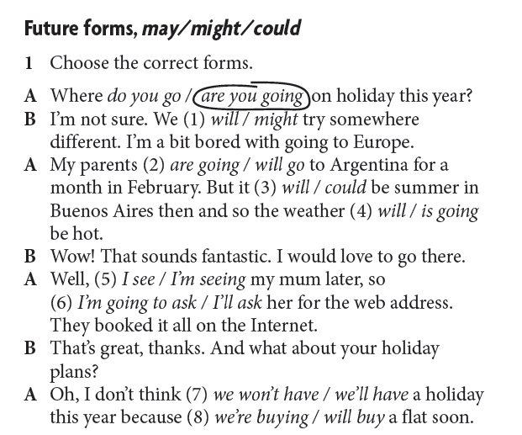

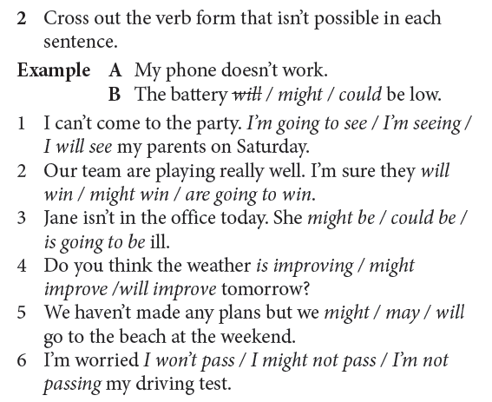

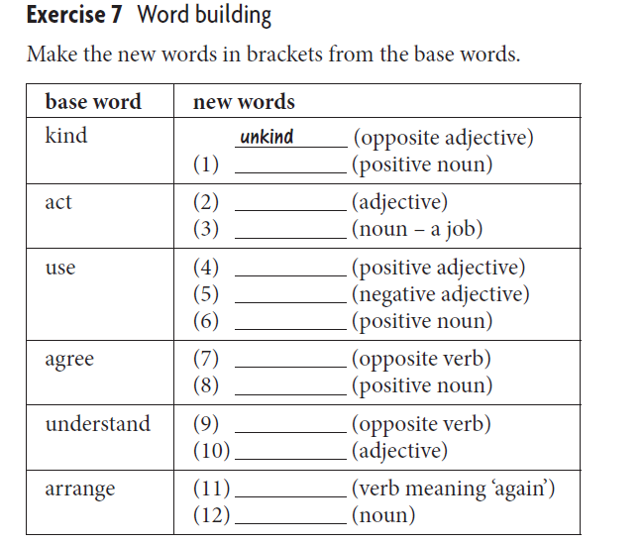

UNIT 5 EXERCISES

1 Underline the correct verb forms.
1 What are you doing this evening?
I’ll go / I’m going to the cinema.
2 Are you going to the bank?
Yes, I’ll go / I’m going there to talk to the manager.
3 Have you got plans for the weekend?
I’m playing / I’ll play golf with Chris.
4 This lesson is so long.
Don’t worry. It might finish / It’ll finish soon.
5 Where are you going for the holiday?
I’m not sure. I may stay / I’m staying here.
6 I’ve booked the tickets but I can’t collect them.
It’s OK, I’m going into town so I could collect / I’m collecting them.
7 Have you seen Tom yet?
No, he’s arriving / he’ll arrive on the six o’clock train.
8 Look at those dark clouds!
Oh dear, it’ll rain / it might rain later.

2 Read the conversation. Underline the correct future forms.
A I’m going / ’ll go to town. Do you want anything?
B Are you going / Will you go to the post office? I need forty stamps.
A Yes, I am. I will apply / am applying for a new driving licence so I’ll get you the stamps at the same time.
B Thanks.
A Why do you need forty stamps? You always send emails.
B Well I’m having / ’ll have a party, so I want to send invitations to everybody.
A If you want me to, I’m buying / ’ll buy the invitations too.
B Thanks, but I’m getting / ’ll get them printed at work. It’s already arranged.
A OK. I’ll see / ’m seeing you later! Bye.

3 In each of these sentences there is a mistake with a future form. Find it and correct it.
1 I will see her tomorrow at 4.30 p.m.

I’m seeing her tomorrow at 4.30 p.m.
2 I go to a concert this evening.
___________________________________________________
3 Greg will helping you move the computer.
___________________________________________________
4 You can ask Alan, but he not help you.
___________________________________________________
5 We will have a party next week.
___________________________________________________
6 Kate catch the train at 3.30 this afternoon.
___________________________________________________
7 They don’t visit us next summer.
___________________________________________________
8 I’m going to go to meet them at the airport.
___________________________________________________

4 Complete the conversation using the prompts in brackets.
1 A It looks like it _________ (be) a beautiful afternoon. Why don’t we go for a walk?
B Great idea! I _________ (get) my coat.
A You _________ (not need) that. The sun’s out. It _________ (not rain).
B I _________ (take) the risk!
2 A There’s a big chance that (5 the company / close) _________.
B That’s terrible. What (6 you / do) _________?
A I _________ (meet) the HR manager tomorrow at 11.00. I don’t want to leave – it _________ (be) difficult for me to find a similar job.
B It’s definite, though, so you _________ (be) OK.

KEY
Future forms, may/might/could
1
1 might 5 I’m seeing
2 are going 6 I’ll ask
3 will 7 we’ll have
4 will 8 we’re buying
2
1 I will see 4 is improving
- might win 5 will
- is going to be 6 I’m not passing

Exercise 7
1 kindness
2 active
3 actor/actress
4 useful
5 useless
6 usefulness
7 disagree
8 agreement
9 misunderstand
10 understandable/understanding
11 rearrange
12 arrangement

UNIT 5 EXERCISES
Exercise 1
2 I’m going
3 I’m playing
4 It’ll finish
5 I may stay
6 I could collect
7 he’s arriving
8 it might rain
Exercise 2
A I’m going to town. Do you want anything?
B Are you going to the post office? I need forty stamps.
A Yes, I am. I’m applying for a new driving licence so I’ll get you the stamps at the same time.
B Thanks.
A Why do you need forty stamps? You always send emails.
B Well I’m having a party, so I want to send invitations to everybody.
A If you want me to, I’ll buy the invitations too.
B Thanks, but I’m getting them printed at work. It’s already arranged.
A OK. I’ll see you later! Bye.
Exercise 3
1 I will to see her tomorrow at 4.30 p.m.
I’m seeing her tomorrow at 4.30 p.m.
2 I go to a concert this evening.
I’m going to a concert this evening.
3 Greg will helping you move the computer.
Greg will help you move the computer.
4 You can ask Alan, but he not help you.
You can ask Alan, but he won’t help you.
5 We will have a party next week.
We’re having a party next week.
6 Kate catch the train at 3.30 this afternoon.
Kate’s catching the train at 3.30 this afternoon.
7 They don’t visit us next summer.
They aren’t going to visit us next summer.
8 I’m going to go to meet them at the airport.
I’m meeting them at the airport.
Exercise 4
1 A It looks like it’s going to be a
beautiful afternoon. Why don’t we
go for a walk?
B Great idea! I’ll get my coat.
A You won’t need that. The sun’s out.
It isn’t going to rain.
B I’ll take the risk!
2 A There’s a big chance that the
company might / may close.
B That’s terrible. What are you going
to do / will you do?
A I’m meeting the HR manager
tomorrow at 11.00. I don’t want to
leave – it’ll be / it’s going to be
difficult for me to find a similar job.
B It isn’t definite, though, so you may
be / might be OK.

